Theme 8

World War I: To Play or Not to Play?

Pupil Activity Sheet 2: Recruitment Posters

Study each of the four posters below.

What would each of these posters have made you think and feel if you had been:
- a professional Northern Union or Association footballer, or
- a physically fit male supporter who was not in an occupation that exempted you from serving in the armed forces?

1.
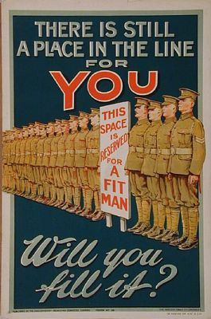

Thoughts:

________________________________

________________________________

________________________________

________________________________

________________________________

________________________________

________________________________

Feelings:

________________________________

________________________________

________________________________

________________________________

________________________________

________________________________

________________________________

2.
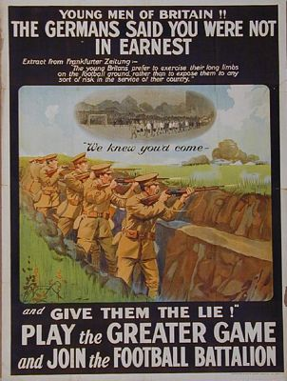

Thoughts:

______________________________________________________________________

______________________________________________________________________

______________________________________________________________________

______________________________________________________________________

______________________________________________________________________

Feelings:

______________________________________________________________________

______________________________________________________________________

______________________________________________________________________

______________________________________________________________________

3.
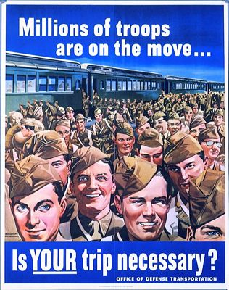

4.
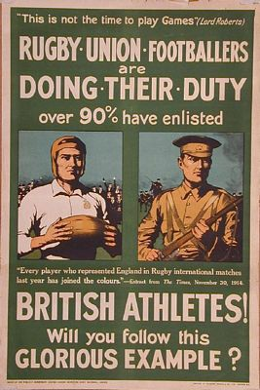

Thoughts:

________________________________

________________________________

________________________________

________________________________

________________________________

Feelings:

________________________________

________________________________

________________________________

________________________________

________________________________

Thoughts:

________________________________

________________________________

________________________________

________________________________

________________________________

________________________________

Feelings:

________________________________

________________________________

________________________________

________________________________

________________________________

________________________________

